Congo, Dem. Rep.

## Political Stability Estimate Data

The data set shows the political stability estimate of the country for a given year and its classification in four categories (unstable, moderately unstable, moderately stable, stable).

## # A tibble: 19 x 5  
## country iso3c date stability stabilityCategory4  
## <chr> <chr> <dbl> <dbl> <chr>   
## 1 Congo, Dem. Rep. ZAR 1996 -2.68 highly unstable   
## 2 Congo, Dem. Rep. ZAR 1998 -2.84 highly unstable   
## 3 Congo, Dem. Rep. ZAR 2000 -2.48 highly unstable   
## 4 Congo, Dem. Rep. ZAR 2002 -1.98 highly unstable   
## 5 Congo, Dem. Rep. ZAR 2003 -2.03 highly unstable   
## 6 Congo, Dem. Rep. ZAR 2004 -2.39 highly unstable   
## 7 Congo, Dem. Rep. ZAR 2005 -2.13 highly unstable   
## 8 Congo, Dem. Rep. ZAR 2006 -2.25 highly unstable   
## 9 Congo, Dem. Rep. ZAR 2007 -2.18 highly unstable   
## 10 Congo, Dem. Rep. ZAR 2008 -2.01 highly unstable   
## 11 Congo, Dem. Rep. ZAR 2009 -2.00 highly unstable   
## 12 Congo, Dem. Rep. ZAR 2010 -2.20 highly unstable   
## 13 Congo, Dem. Rep. ZAR 2011 -2.21 highly unstable   
## 14 Congo, Dem. Rep. ZAR 2012 -2.09 highly unstable   
## 15 Congo, Dem. Rep. ZAR 2013 -2.19 highly unstable   
## 16 Congo, Dem. Rep. ZAR 2014 -2.17 highly unstable   
## 17 Congo, Dem. Rep. ZAR 2015 -2.15 highly unstable   
## 18 Congo, Dem. Rep. ZAR 2016 -2.23 highly unstable   
## 19 Congo, Dem. Rep. ZAR 2017 -2.30 highly unstable

## Political Stability Estimate Plot

The plot shows the trends of stabilization and destabilization for the each country.

A stabilization trend can be classified as absolute, if the stability scores move from unstable or moderately unstable to moderately stable or stable (that is, crossing up the red line). The trend can be considered relative, if the scores remain in the same positive or negative areas. Similarly, a destabilization trend can be classified as absolute, if the stability scores move from stable or moderately stable to moderately unstable or unstable (that is, crossing down the red line). The trend is considered relative, if the scores remain in the same positive or negative areas.

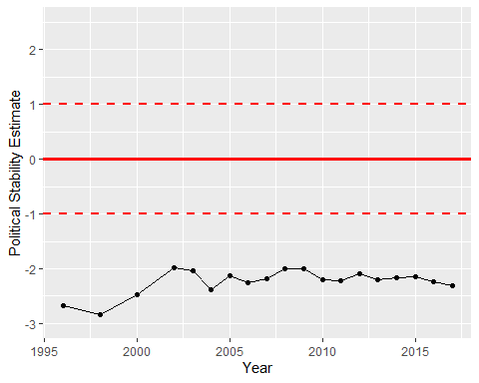

Political Stability Trend